# TaskerCLI

## Activity Diagrams

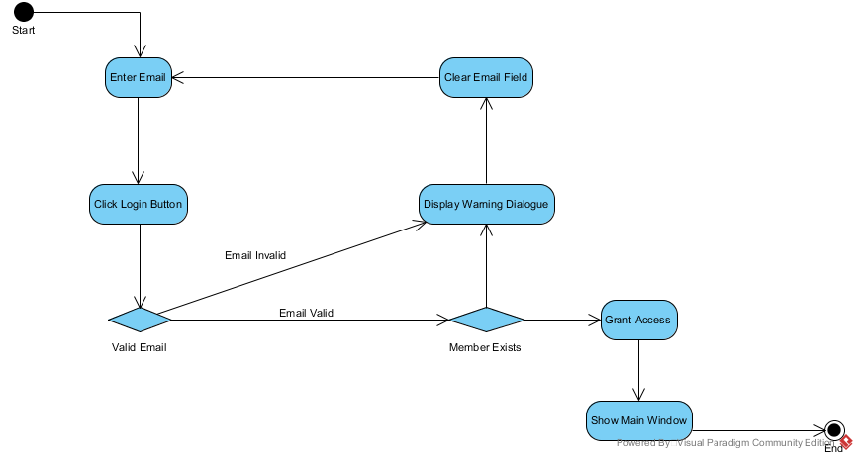

### Login

### Connecting to TaskerSRV

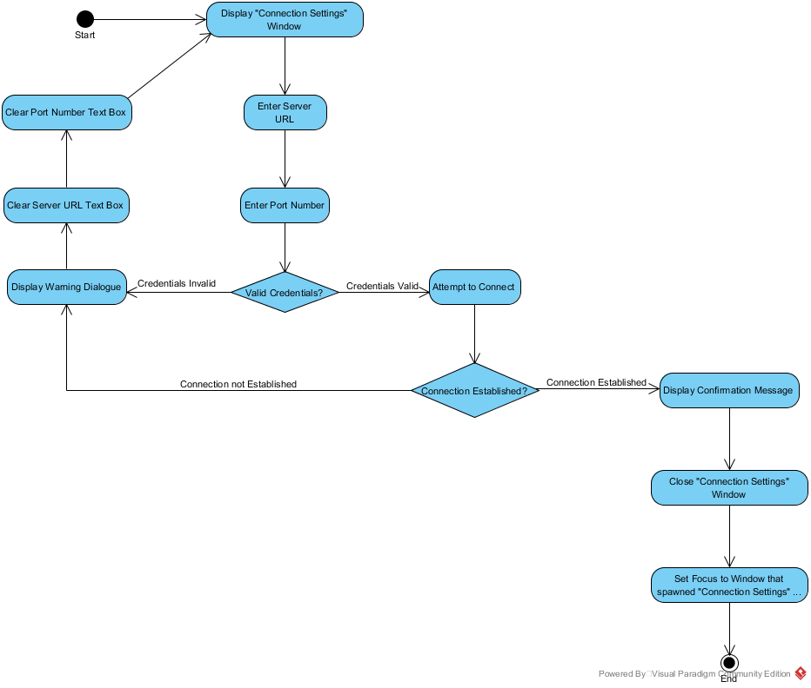

### Editing a task

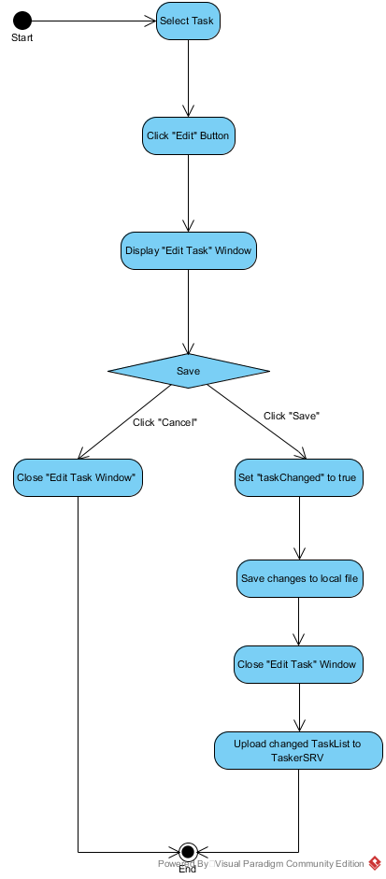

## Class diagrams

**1.2.1 Logic Class Diagram**

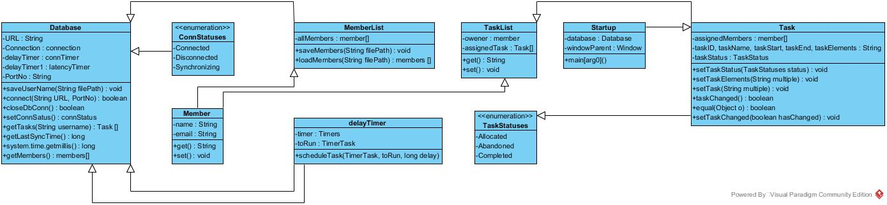

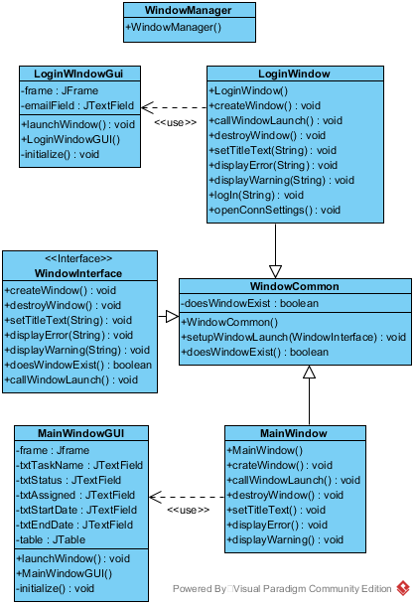**1.2.2 GUI Class Diagram**

## Significant Data Structures

### Database class structure

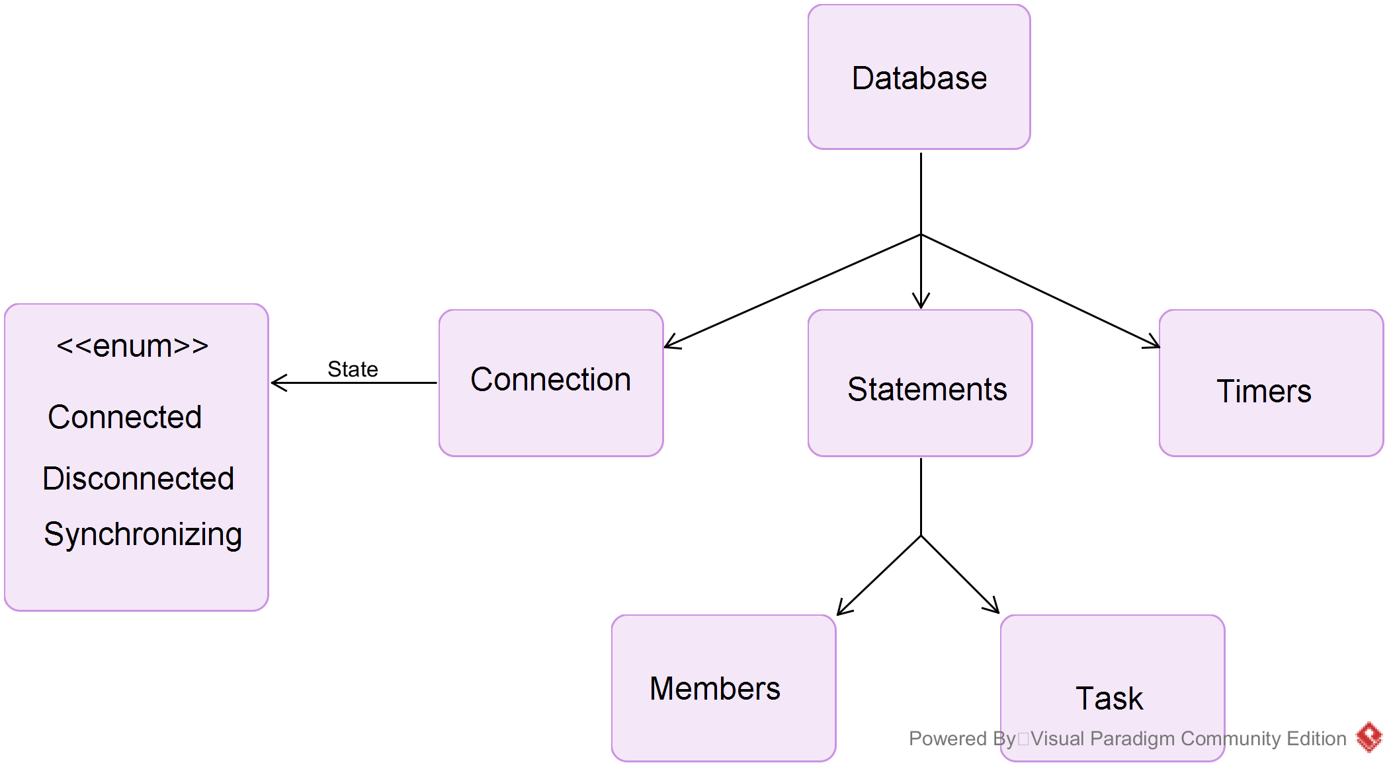

### Members and Tasks Structure

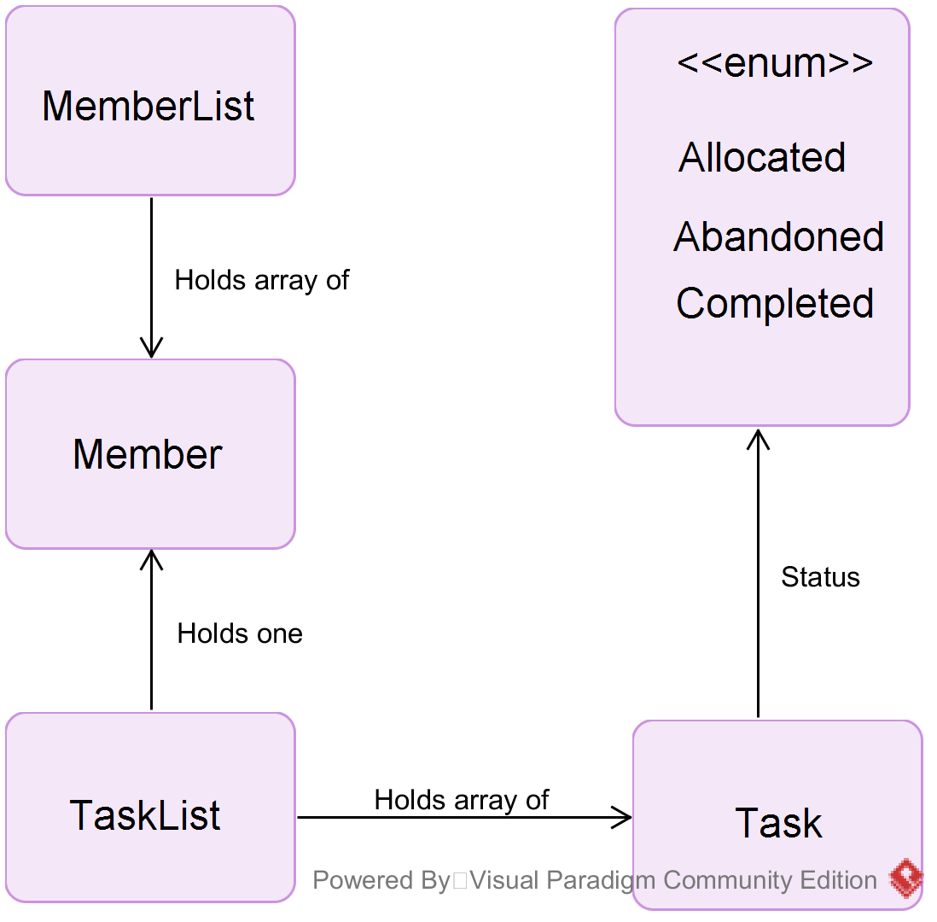

## Class Interfaces

### Logic Class Interfaces

Database:

void saveUsernames(String filePath);

bool connect(String URL, String filePath);

bool closeDbConn();

connStatus setConnStatus();

Task[] getTasks(String username);

Long getLastSyncTime();

Long System.Time.getmillis()

Members[] getMembers();

Task:

void SetTaskStatus(TaskStatuses Status);

void SetTaskElements();

void SetTask(String);

bool TaskChanged();

bool Equal (object 0);

void SetTaskChanged(bool hasChanged);

Member:

String getName();

String getEmail();

void setName();

void setEmail();

DelayTimer:

Void ScheduleTask(TimerTask toRun, Long delay);

MemberList:

Member[] all members;

void saveMembers (String filePath);

members[] loadMembers(String filePath);

verifyMember(String username);

TaskList:

Member getOwner();

Task[] getAssignedTasks();

void setOwner();

void setAssignedTasks();

TaskElement:

void setElementName();

void setElementComment();

String getElementName();

String getElementComment();

### GUI Class Interfaces

Window:

void populateWindowArray();

void initialize (windowIndex, windowName);

void exit(windowIndex, windowName);

void setFocus(windowIndex, windowName);

## Sequence Diagrams

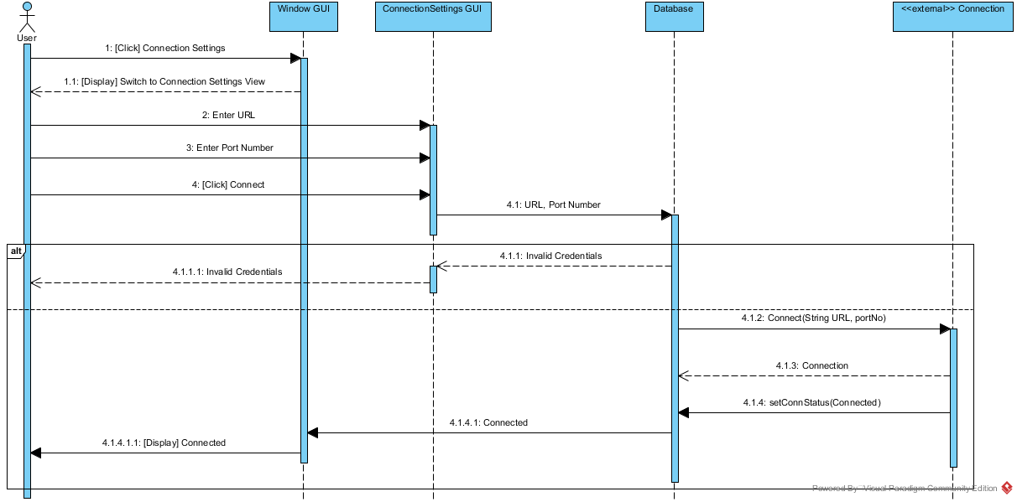

### Connecting to TaskerSRV

### Database Synchronisation

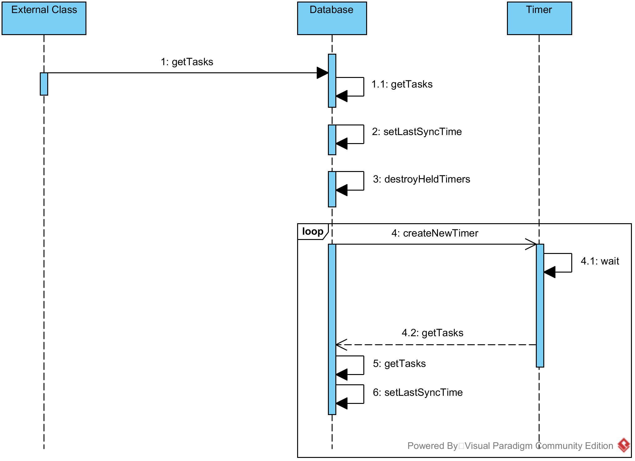

### User Login

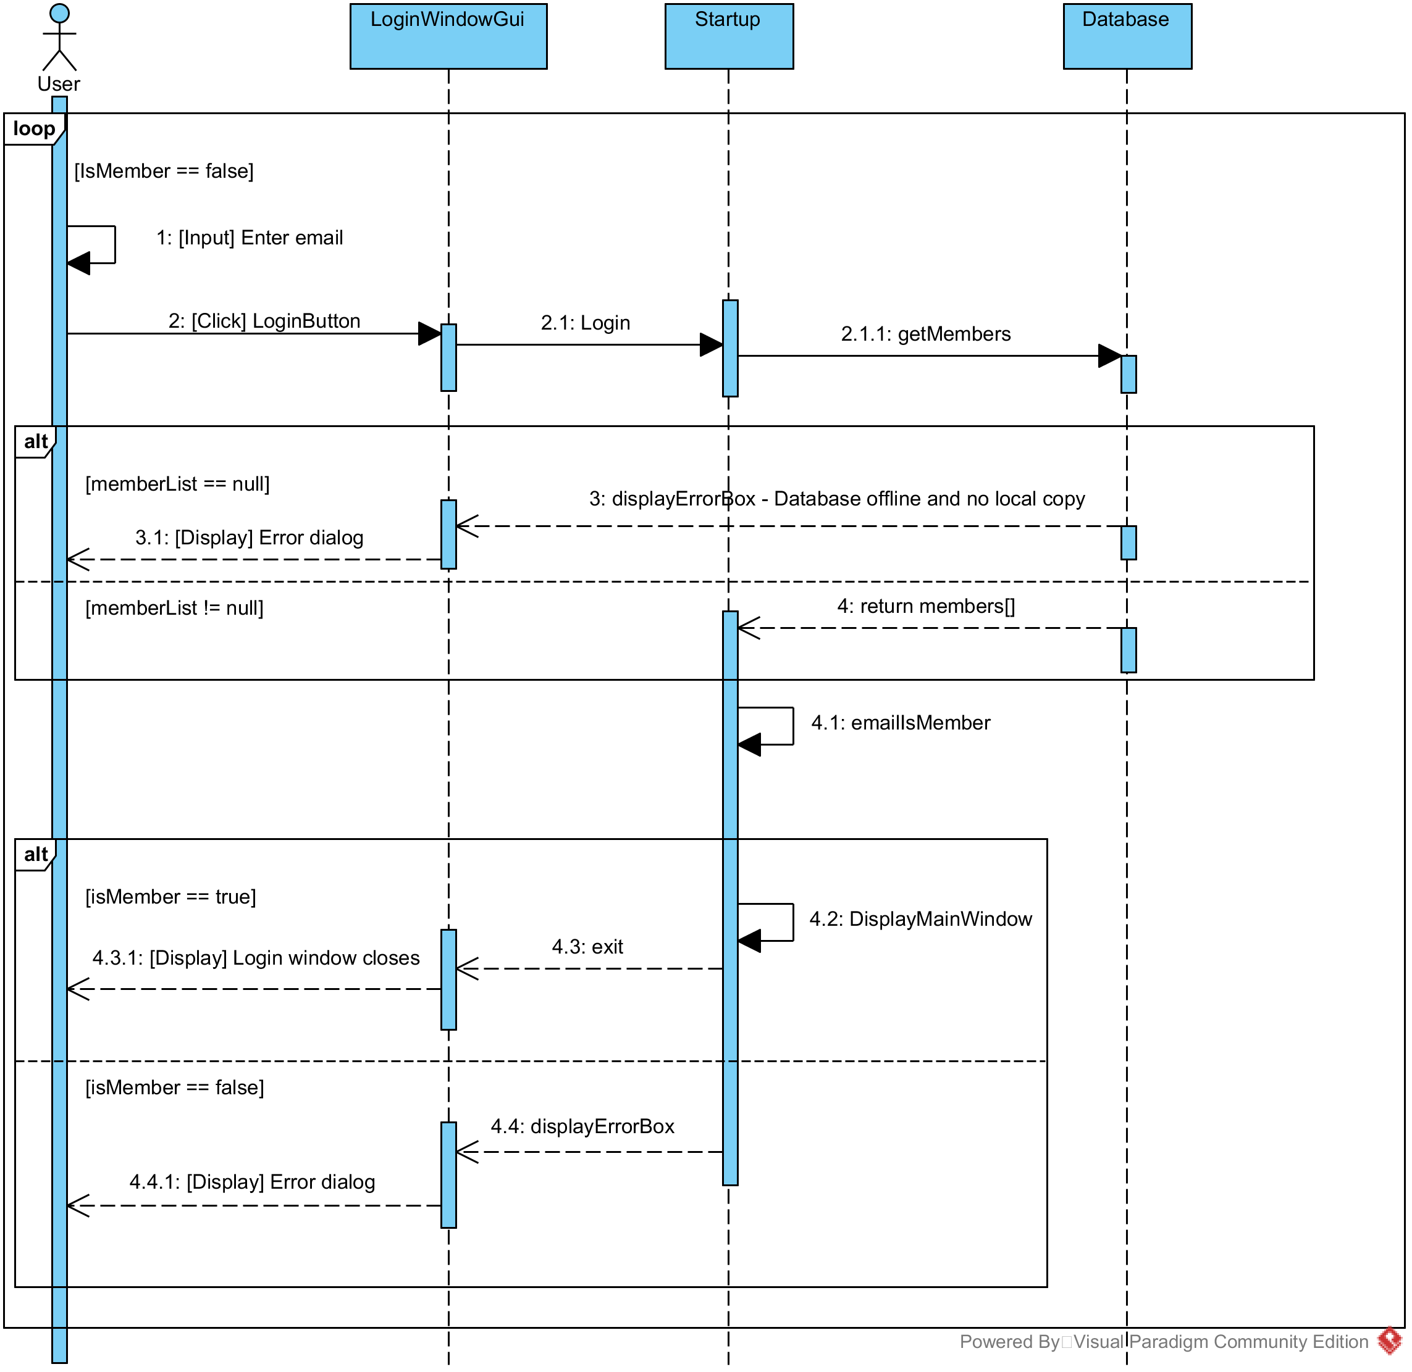

### Database Members Synchronisation

### 

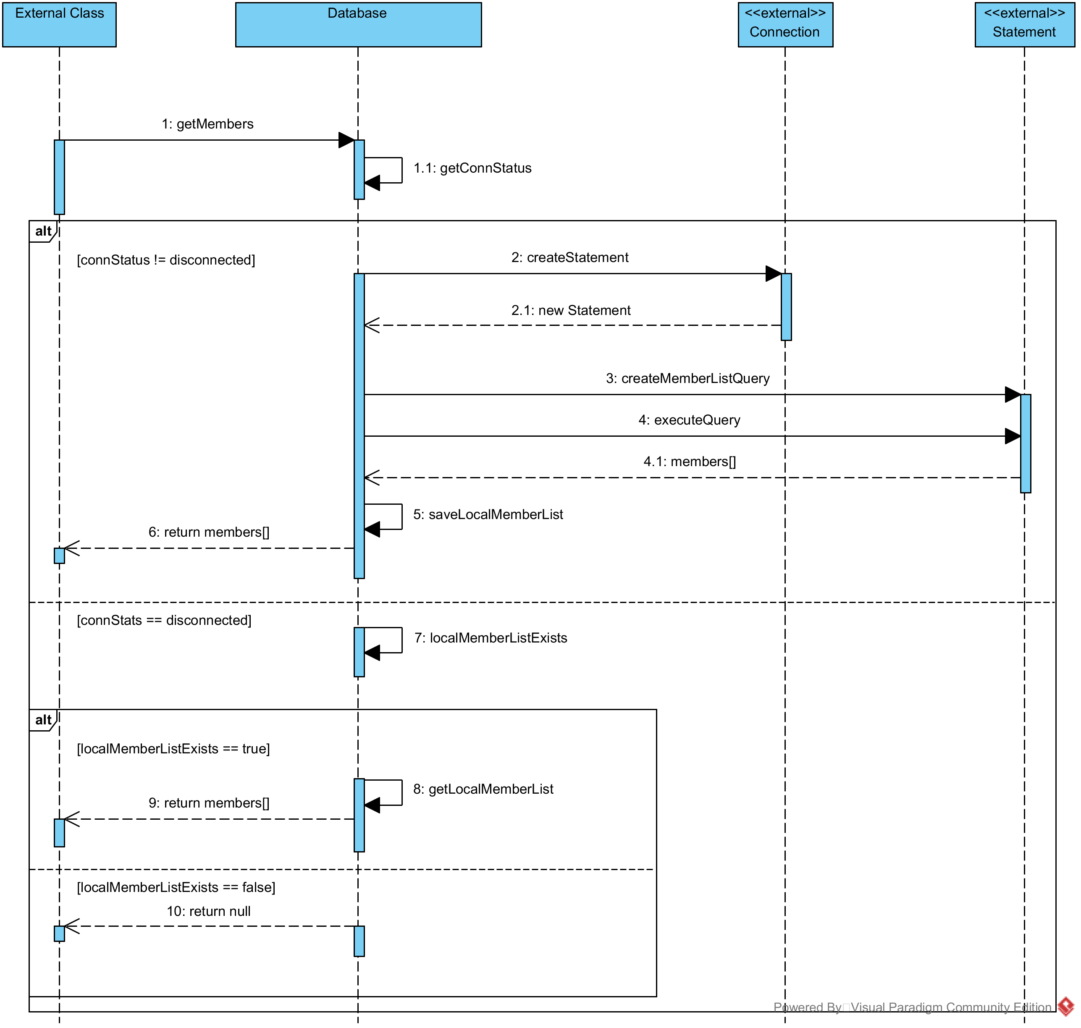

### Database Tasks Synchronisation

### 

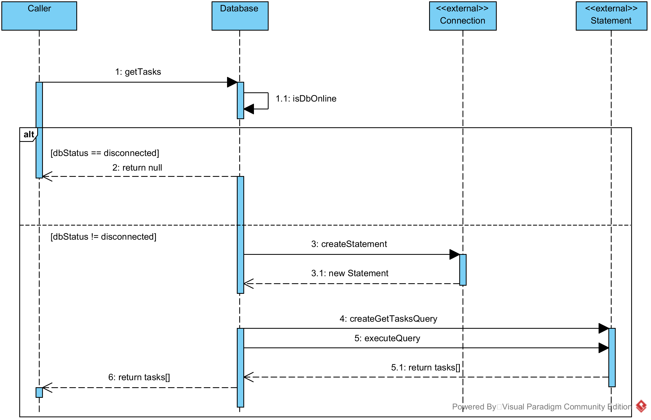

### Editing Tasks

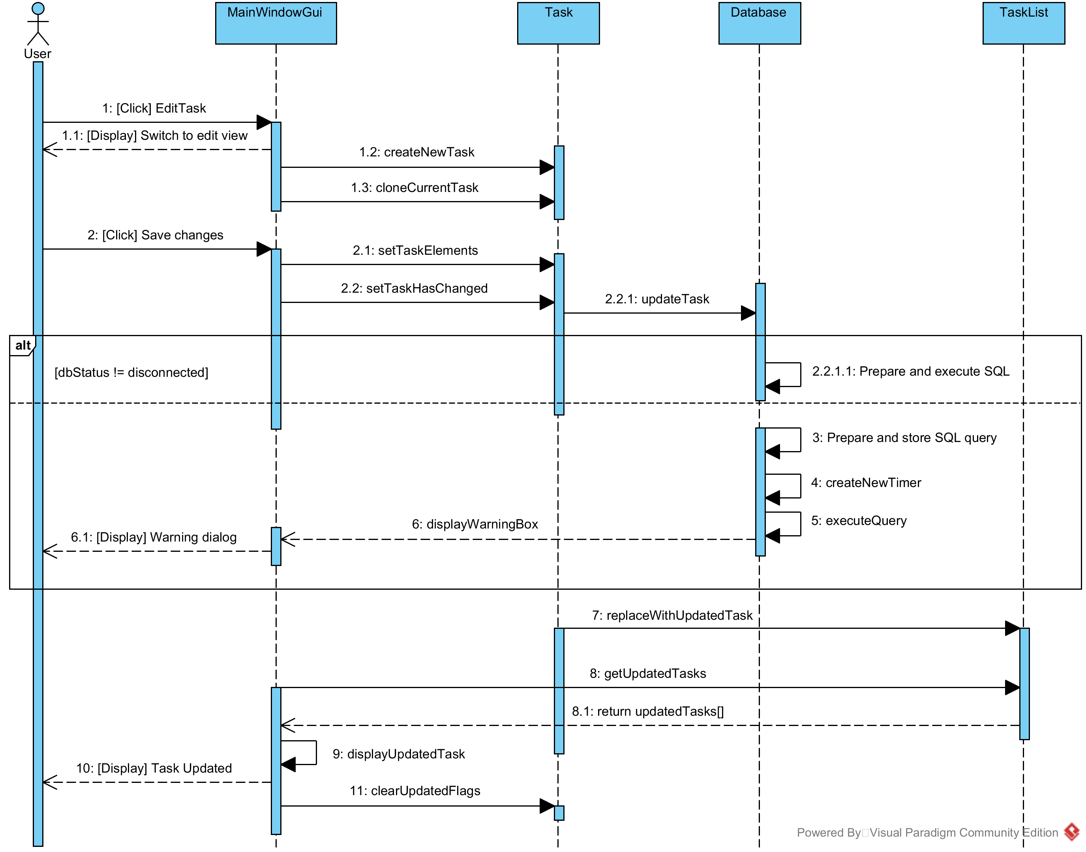

## DOCUMENT HISTORY

| *Version* | *CCF No.* | *Date* | *Changes made to document* | *Changed by* |
| --- | --- | --- | --- | --- |
| 1.0 | N/A | 12/09/08 | N/A - original version | CJP |
| 1.1 | N/A | 2010-10-12 | Updated to Office 2007; key field automation increased; paragraph styles updated | NWH |
| 1.2 | N/A | 2011-10-10 | Typos | NWH |
| 1.3 | N/A | 2015-10-16 | Update for Office 2013 | NWH |